Article
Investigation of PelA Gene Expression in Pseudomonas aeruginosa and Its Impact on Biofilm Formation

Mohammed Asim Ismael*¹
- The Sunni Endowment, Diyala, Iraq
Citation: Ismael, M. A. Investigation of PelA Gene Expression in Pseudomonas aeruginosa and Its Impact on Biofilm Formation. Central Asian Journal of Medical and Natural Science 2025, 6(4), 2097-2104.
Received: 30th Jun 2025
Revised: 11th Jul 2025
Accepted: 31th Jul 2025
Published: 31th Aug 2025

Copyright: © 2025 by the authors. Submitted for open access publication under the terms and conditions of the Creative Commons Attribution (CC BY) license (https://creativecommons.org/licenses/by/4.0/)
* Correspondence: Mohammed_asim2002@yahoo.com
Abstract: Pseudomonas aeruginosa forms a biofilm extracellular matrix comprising proteins, lipid vesicles, nucleic acids, and exopolysaccharides that render it pathogenic and resistant to antimicrobial treatment. A total of 24 P. aeruginosa isolates, both meropenem-sensitive and meropenem-resistant, were tested in this work, and all of them exhibited biofilm production. Interestingly, meropenem treatment served to repress the expression of the PelA gene, an essential part of biofilm formation, to a significant degree. The results implicate that meropenem, when administered at minimum inhibitory concentrations (MICs), is potentially reducing the virulence of P. aeruginosa, opening a window against bacterial resistance, in addition to lowering the requirement for high-dose antibiotic therapy and the risk of deleterious side effects.
Keywords: PelA, Biofilm, Meropenem Antibiotic, RT-qPCR
- Introduction
Pseudomonas aeruginosa is a versatile, opportunistic, Gram-negative, non-fermenting bacterium that is prone to infections in humans, especially in debilitated individuals like hospitalized patients and immunocompromised ones. Pseudomonas aeruginosa has a broad spectrum of diseases ranging from localized ones like dermatitis and soft tissue infection to systemic infections like sepsis, respiratory tract infections, and bacteremia. The organism is capable of causing chronic infection especially in patients with compromised health like cystic fibrosis or severe burns. These P. aeruginosa infections, especially those in burn patients, are extremely ominous as they possess a high rate of death and disability, along with the additional fact that the bacterium is resistant to a range of antibiotics and also possesses the ability to form biofilms, which present a physical barrier for immune assault and antimicrobial agents [1].
The ability of P. aeruginosa to develop biofilms is one of the primary reasons for its pathogenicity and survival in infected tissues. Biofilms are structured, heterogenous microbial communities surrounded by an extracellular matrix composed of a variety of substances, including exopolysaccharides, extracellular DNA, and proteins. P. aeruginosa produces multiple exopolysaccharides such as alginate, Psl, and Pel, which contribute to biofilm formation and stability. These exopolysaccharides are the major players in biofilm stability, immunity from host immune defense, and antimicrobial resistance. Synthetic Pel and Psl, in particular, play an essential role in making the biofilm shield bacteria from the effect of antibiotics and from being attacked by the host immune system [2].
The highest distinctive feature of P. aeruginosa is its very high level of adaptability. Most of its strains are very prone to utilize either Pel or Psl depending on the situations. However, under certain stressful conditions such as against antibiotics or host immunity, P. aeruginosa will switch between Pel and Psl production [3]. This toggle capacity to modify biofilm structure in response to environmental stress provides the pathogen with the capacity to sustain persistence and virulence in the host as well as render treatment and eradication challenging. This adaptive process intimates the need for targeted therapies that selectively eliminate both Pel and Psl production as well as other biofilm formation mechanisms in a bid to maximize treatment regimens. The development of antibiotic resistance in P. aeruginosa is directly correlated with its ability to develop biofilms, which provide a protective niche from where bacteria are able to survive extreme conditions, including exposure to antibiotics. Bacteria that are part of biofilms are also more resistant to antimicrobial agents than are their free-living counterparts, and this occurs in part through the protective matrix and altered metabolic condition. P. aeruginosa is, therefore, a formidable enemy for physicians, particularly when infections in susceptible hosts or aggressive medical care need to be addressed [4, 5, and 6].
The aim of this research was to examine the biofilm-forming ability of P. aeruginosa isolates and measure the expression of the PelA gene, a key regulator of Pel exopolysaccharide synthesis, before and after exposure to the antibiotic meropenem. Upon analyzing these parameters, we tried to understand more about how meropenem influences biofilm formation and gene expression in the hopes of making more effective treatments that can cure P. aeruginosa infection, particularly the infections that depend on biofilm formation and antibiotic resistance.
- Materials and Methods
Specimen's collection
For the purpose of this study, 120 clinical specimens were collected between October 2023 and April 2024. Samples were taken from Iraqi patients from Medical City who had burns and wounds.
Isolation and Identification
Each of the environmental or clinical samples was initially streaked onto cetrimide agar plates, which selectively allow for the growth of Pseudomonas species, and incubated at 37 °C for 24 hours under aerobic conditions to achieve maximum growth of the bacteria. Typical morphology colonies were subsequently isolated for purification. Specifically, lactose-non-fermenting colonies were streaked onto MacConkey agar plates for pure strain isolation. These colonies were then re-picked and re-cultured on fresh agar plates to produce well-isolated and morphologically consistent colonies which were available for identification.
For accurate identification of the bacterial isolates, a combination of automated and phenotypic techniques was employed. Rapid biochemical identification and antimicrobial susceptibility testing were performed on the VITEK® 2 compact system. This was complemented by traditional diagnostic tools like macroscopic and microscopic examination of the colony morphology, Gram staining, and an array of standard biochemical tests to determine the identity and characterization of the bacterial strains.
Biofilm formation assay
The quantification from biofilm formation was conducted utilizing a Microliter Plate assay outlined by [7, 8].
The effects of Meropenem at MIC on biofilm formation
Meropenem MIC was determined, and the antibacterial activity was assessed following an 18–24-hour incubation period at 37°C. MIC was determined the lowest concentration from test samples.
Gene expression for Pel A gene of P. aeruginosa
RNA was harvested from 24 selected isolates of P. aeruginosa utilizing the FavorPrep Total RNA Mini Kit in accordance with the manufacturer's guidelines. Subsequently, the RNA was converted to cDNA using the EasyScript ® First-Strand cDNA Synthesis Super Mix.
For gene expression analysis of PelA, specific primers were utilized: Forward primer CCTTCAGCCATCCGTTCTTCT and Reverse primer TCGCGTACGAAGTCGACCTT(8). Additionally, 16SrRNA was used as a housekeeping gene with Forward primer CAGCTCGTGTCGTGAGATGT and Reverse primer GCGTAAGGGCCATGATGACTT.
Expression levels were quantified through relative quantitation by assessing the variance in cycle thresholds (ΔCt) and fold changes before and after meropenem treatment in conjunction with the housekeeping gene.
Statistical analysis
Statistical analysis to determine the effect of the parameters in this study, Microsoft Excel 2013 was used.
- Results and Discussion
The research involved microbiological processing of 120 clinical specimens with 80 swabs collected from burn injuries and 40 swabs collected from wound infections. In order to improve recovery and accurate identification of Pseudomonas aeruginosa, each sample was plated onto a combination of differential and selective media like MacConkey agar, blood agar, and cetrimide agar. MacConkey agar was employed to differentiate lactose-fermenting from non-lactose-fermenting Gram-negative bacteria, but blood agar stimulated the growth of a broad range of organisms and helped determine hemolytic activity. Cetrimide agar, which is P. aeruginosa selective, also was employed to enhance the isolation of the test pathogen.
When incubated under appropriate conditions, 100 out of the 120 treated samples (83%) showed positive bacterial growth and no microbial growth was seen in 20 samples (17%). Although 24% (24 out of 100) of the culture-positive specimens were confirmed as P. aeruginosa based on colonial morphology, pigmentation, and additional biochemical and automated identification. The remaining 76% (76 of 100) of the isolates were other bacteria from other bacterial genera, indicating diversity in microbial flora among the clinical specimens analyzed.
The frequency and distribution of P. aeruginosa in relation to other bacterial isolates are summarized in Table 1 and graphically illustrated in Figure 1. The data presented reflects the moderate frequency of P. aeruginosa among burn and wound infections in the examined population and highlights the need for special diagnostic techniques in clinical microbiology laboratories.

Table 1. Isolates of bacteria extracted from the samples.
Isolate | No. | %
Pseudomonas aeruginosa | 24 | 24
Others | 76 | 76
Total | 100 | 100

Figure 1. Positive culture from the Samples.

Figure 2 illustrates morphological appearance of P.aeruginosa colonies on MacConkey agar medium.

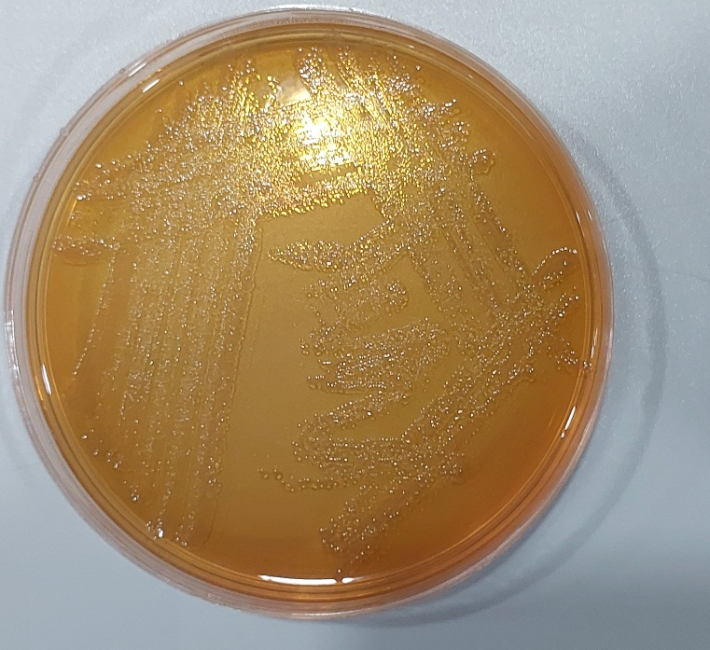
Figure 2. MacConkey agar for the isolation P. aeruginosa.

The results, for biofilm production, showed that all P. aeruginosa isolates (no=24) (100%) isolates were found positive for biofilm production by Tissue Culture Plate TCP method (TCPM) which is postulated to be a gold standard for biofilm detection.
Our result findings found that the phenotypic detection were also good biofilm producers, 100% (24/24), 0% (0/24) for poor biofilm and fair biofilm producers, as shown in Table 2, and Figure 3, 4.

Table 2. Biofilm formation by P. aeruginosa.
Biofilm | No. | %
Weak | 0 | 0
Moderate | 0 | 0
Strong | 24 | 100

Figure 3. Percentage of Biofilm formation by P. aeruginosa.

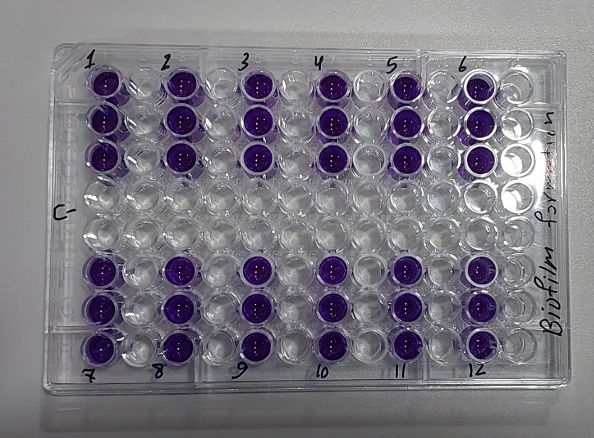
Figure 4. Results of Biofilm formation by P. aeruginosa.

The impacts of the antibacterial activity of the antibiotic meropenem in MIC were outlined in Figure 5. Three isolates (37.5%) alone were inhibited from growth at levels of 4 µg/ml, whereas 62% of the P. aeruginosa isolates (5/8) were at levels of 2 µg/ml.
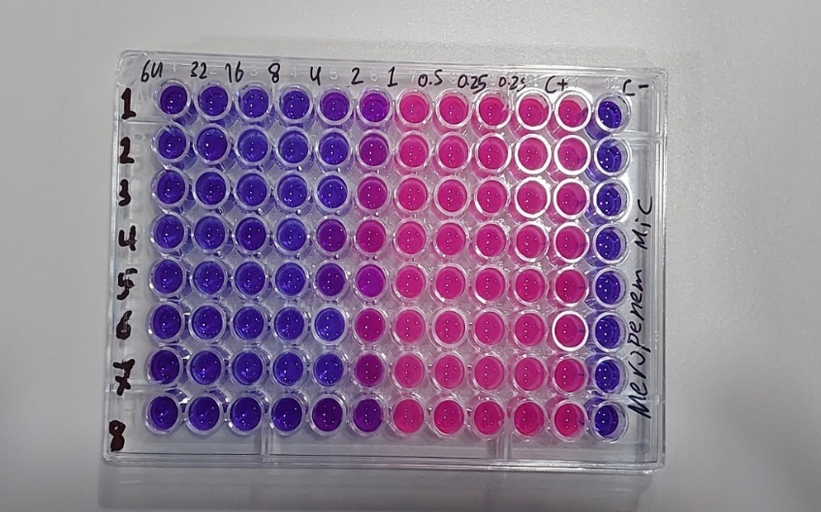
Figure 5. The results of broth microdilution method to MIC values of meropenem antibiotic against P. aeruginosa.
Different MIC levels of meropenem (0.2,0.25,0.5,1,2, 4,8, 16, 22, and 64μg /ml) were used to describe the isolates and investigate the expression of PelA of P. aeruginosa biofilm using RT-qPCR.
The mean± SE level of PelA decrease in gene expression after Treatment with meropenem antibiotic when compared with Before Treatment with meropenem antibiotic significantly change P- value 0.0001. As seen in table 3, and figure 6.

Table 3. The expression levels of the PelA gene in relation to the fold change before and after being subjected to the meropenem antibiotic were assessed using RT-PCR.
2^^{- ΔΔCT} (Fold change)
Mean ±SE
Before Treatment with  meropenem antibiotic | After Treatment with  meropenem antibiotic
1.082±0.389 | 0.183±0.053
P-value = 0.0001
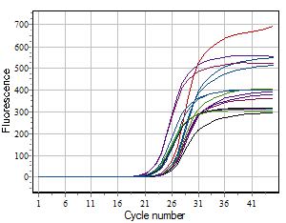
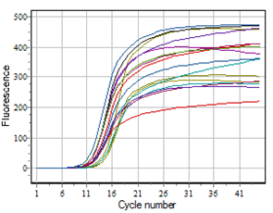
Figure 6. RT-PCR was used to amplify the PelA cDNA product and 16S RNA genes.

Numerous studies have investigated the role of quorum sensing in regulating the virulence of Pseudomonas aeruginosa. Given the increasing prevalence of antibiotic resistance, identifying alternative therapeutic strategies beyond conventional antibiotics has become a central focus in health research [9]. Beenken et al. [10] proposed that variations in biofilm thickness observed among clinical isolates may be attributed to several factors, including differences in each isolate’s inherent ability to form biofilms and variability in the initial number of adherent bacterial cells during early biofilm development.
Furthermore, they reported that individual isolates produce varying quantities and qualities of quorum-sensing signaling molecules. Importantly, aside from mild biofilm formation, there appears to be no consistent pattern in the distribution of biofilm intensities among samples; rather, the degree of biofilm formation is unique to each isolate [11]. This observed heterogeneity may stem from underlying genetic divergence among strains. These findings are consistent with those reported in other regional investigations [12,13] and align with broader international literature. [14,15] The excessive biofilm production observed in the present study could also be due to the excessive sensitivity of the TCPM (Tissue Culture Plate Method), as it can measure even very slight levels of biofilm production. The method is particularly beneficial for investigating the early onset of biofilms, as it maintains constant conditions and allows measurement of the most important virulence determinants, including pili and flagella. In addition, the TCPM method has been widely applied to determine the biofilm-forming capacity of various bacterial strains [16].
Earlier studies have established a strong relationship between biofilm production and expression of the pelA gene, with some studies indicating that up to 80% of P. aeruginosa strains that produce biofilms express the gene [17]. The study also states that all strains of P. aeruginosa that produce biofilms carry the pelA gene [17]. However, contrary findings are documented; for instance, another study had recovered pelA in only 45.2% of isolates [18], while another study had recovered it in 57.3% of strains [19].
There was a statistically significant reduction in the expression of the pelA gene following treatment with the drug meropenem (P = 0.0001), in comparison to pre-treatment. Such post-treatment suppression of pelA expression in the bacteria may be a marker for an adaptive response of the bacterial population to the antibiotic that may reflect the emergence of new resistance mechanisms and the first phases of creating antibiotic resistance [20]. These findings need to be further studied to confirm the same as well as to examine potential ways to counteract resistance development in P. aeruginosa.
- Conclusion
This study centers on the critical function of the PelA gene for biofilm formation in Pseudomonas aeruginosa. Biofilms were produced by all 24 isolates, and meropenem treatment with MIC concentrations was highly effective at inhibiting PelA gene expression. This suggests that meropenem can inhibit bacterial virulence by inhibiting biofilm-associated gene expression, potentially making therapy possible at sub-MIC levels. Future work to be undertaken is to look into the molecular mechanism behind such suppression, to expand the investigation to more isolates, and to measure gene expression across time and with varying concentrations of drugs. Another challenge of these results by combination therapy and in vivo confirmation could further legitimize the application of meropenem as a double-barreled drug—both antimicrobial and anti-virulence.

REFERENCES
  - A. K. Fakhry and A. O. Aljanabi, "The Effect of Pseudomonas Infection with Burns Patients," Journal of Current Medical Research and Opinion, vol. 7, no. 02, pp. 2135-2157, 2024.
  - S. Roy, P. Mukherjee, S. Kundu, D. Majumder, V. Raychaudhuri, and L. Choudhury, "Microbial infections in burn patients," Acute and Critical Care, 2024.
  - F. A. Abdi, A. N. Motumma, A. A. Kalayu, and W. E. Abegaz, "Prevalence and antimicrobial-resistant patterns of Pseudomonas aeruginosa among burn patients attending Yekatit 12 Hospital Medical College in Addis Ababa, Ethiopia," Plos One, vol. 19, no. 3, e0289586, 2024.
  - D. Campoccia, L. Montanaro, and C. R. Arciola, "Extracellular DNA (eDNA): A major ubiquitous element of the bacterial biofilm architecture," International Journal of Molecular Sciences, vol. 22, no. 16, pp. 9100, 2021.
  - L. Z. Ma, D. Wang, Y. Liu, Z. Zhang, and D. J. Wozniak, "Regulation of biofilm exopolysaccharide biosynthesis and degradation in Pseudomonas aeruginosa," Annual Review of Microbiology, vol. 76, pp. 413-433, 2022.
  - K. R. Iyer, N. M. Revie, C. Fu, N. Robbins, and L. E. Cowen, "Treatment strategies for cryptococcal infection: challenges, advances and future outlook," Nature Reviews Microbiology, vol. 19, no. 7, pp. 454-466, 2021.
  - S. Stepanović, D. Vuković, V. Hola, G. D. Bonaventura, S. Djukić, I. Ćirković, and F. Ruzicka, "Quantification of biofilm in microtiter plates: overview of testing conditions and practical recommendations for assessment of biofilm production by staphylococci," Apmis, vol. 115, no. 8, pp. 891-899, 2007.
  - M. A. R. H. Al-Sheikhly, L. N. Musleh, and H. J. Al-Mathkhury, "Gene expression of pelA and pslA in Pseudomonas aeruginosa under gentamicin stress," Iraqi Journal of Science, pp. 295-305, 2020.
  - S. Qin, W. Xiao, C. Zhou, Q. Pu, X. Deng, L. Lan, et al., "Pseudomonas aeruginosa: pathogenesis, virulence factors, antibiotic resistance, interaction with host, technology advances and emerging therapeutics," Signal Transduction and Targeted Therapy, vol. 7, no. 1, p. 199, 2022.
  - K. E. Beenken, L. N. Mrak, L. M. Griffin, A. K. Zielinska, L. N. Shaw, K. C. Rice, et al., "Epistatic relationships between sarA and agr in Staphylococcus aureus biofilm formation," PloS One, vol. 5, no. 5, e10790, 2010.
  - K. A. Simanek, M. L. Schumacher, C. P. Mallery, S. Shen, L. Li, and J. E. Paczkowski, "Quorum-sensing synthase mutations re-calibrate autoinducer concentrations in clinical isolates of Pseudomonas aeruginosa to enhance pathogenesis," Nature Communications, vol. 14, no. 1, p. 7986, 2023.
  - B. A. M. Al-Sabawi, "Gene Expression Variation of Some Virulence Factors of Pseudomonas aeruginosa Isolated from Some Pathogenic and Environmental Cases," M.Sc. thesis, Dept. of Biology, College of Science, University of AL-Anbar, Iraq, 2017.
  - H. F. L. Al-Dulami, "Assessment The Effect of Quorum Sensing Genes (lasI, rhlI) and Some Plant Extracts on Some Virulence Factors of Pseudomonas aeruginosa Isolated from Different Clinical Sources," M.Sc. thesis, Dept. of Biology, College of Science, University of Anbar, Iraq, 2017.
  - J. L. Costa-Limaa, L. R. Alves, P. R. L. Araújo Jacomé, J. P. B. Netoc, M. A. V. Maciel, and M. M. C. Morais, "Biofilm production by clinical isolates of Pseudomonas aeruginosa and structural changes in LasR protein of isolates non biofilm-producing," Braz. J. Infect. Dis., vol. 22, no. 2, pp. 129–136, 2018.
  - P. Maita and K. Boonbumrung, "Association between biofilm formation of P. aeruginosa clinical isolates versus antibiotic resistance and genes involved with biofilm," J. Chem. Pharm. Res., vol. 6, no. 5, pp. 1022-1028, 2014.
  - A. Bhardwaj, "A comparative appraisal of detection of biofilm production caused by uropathogenic Escherichia coli in tropical catheterized patients by three different methods," Asian Journal of Pharmaceutics (AJP), vol. 12, no. 04, 2018.
  - I. Sharma and D. Choudhury, "Detection of Pel A gene in P. aeruginosa from clinical samples using polymerase chain reaction with reference to biofilm production in NE India," Ind J Res, vol. 4, pp. 119-121, 2015.
  - A. Ghadaksaz, A. A. I. Fooladi, H. M. Hosseini, and M. Amin, "The prevalence of some Pseudomonas virulence genes related to biofilm formation and alginate production among clinical isolates," Journal of Applied Biomedicine, vol. 13, no. 1, pp. 61-68, 2015.
  - A. Pournajaf, S. Razavi, G. Irajian, A. Ardebili, Y. Erfani, S. Solgi, et al., "Integron types, antimicrobial resistance genes, virulence gene profile, alginate production and biofilm formation in Iranian cystic fibrosis Pseudomonas aeruginosa isolates," Infez Med, vol. 26, no. 3, pp. 226-36, 2018.
  - R. Yin, J. Cheng, J. Wang, P. Li, and J. Lin, "Treatment of Pseudomonas aeruginosa infectious biofilms: Challenges and strategies," Frontiers in Microbiology, vol. 13, p. 955286, 2022.

